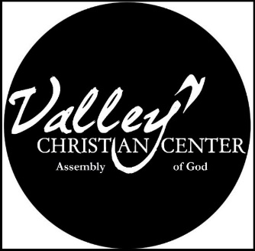
Valley Christian Center AG
448 Maple ST, Myrtle Point OR 97458

Relevant Teaching * Heartfelt Worship * Good Fellowship
Spreading Contagious Godly love 1life@a.time
¯¯¯¯¯¯¯¯¯¯¯¯¯¯¯¯¯¯¯¯¯¯¯¯¯¯¯¯¯¯¯¯¯¯¯¯¯¯¯¯¯¯¯¯¯¯¯¯¯¯¯¯¯¯¯¯¯¯¯¯¯¯¯¯¯¯¯¯¯¯¯¯¯¯¯¯¯
EXPECTATION OF MEMBERS

- Protect the UNITY of the Church:
  - A. By action in love toward other members. 1 PETER 1:22
  - By refusing to gossip. EPHESIANS 4:29
  - By following godly leadership HEBREWS 13:17

- Share the RESPONSIBILITY of this church:
  - By praying for its growth and healthy 1 THESSALOINIANS 1:1-2
  - By inviting the unchurched to attend. LUKE 14:23
  - By warmly welcoming those who visit. ROMANS 15:7

- Serve the MINISTRY of this church:
  - By discovering my gifts and talends 1 PETER 4”10
  - By being equipped by my pastors EPHESIANS 4:11-12
  - By developing a servant’s heart PHILLIPPIANS 2:3-4,7

- Support the TESTIMONY AND MINISTRY of this church:
  - By attending faithfully. HEBREWS 10:25
  - By living a godly life. PHILIPPIANS 1:27
  - By giving regularly 1 CORINTHIANS 16:2, LEVITICUS 27:30
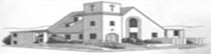
THE MEMBERSHIP COVENANT
Having received Christ as my Lord and Savior and been baptized, and being in agreement with this church’s statements, strategy, and structure, I now l feel led by the Holy Spirit to unite with the church family In doing so, I commit myself to God and the other members to fulfill the aforementioned expectations of membership.

_____________________________________________ _______________
Signature Date

